Ex. No. 1 | Basic Structure of a HTML program
Date of Exercise | 17.07.2026
GitHub Host Link | https://abin-shaji-thomas.github.io/Web-Technology-Lab/Experiment-1/

Aim
To design and develop a simple Infosys Employee Training Portal webpage using basic HTML elements, attributes, hyperlinks, images, lists, and inline CSS for formatting and styling.
Description
This experiment demonstrates the creation of a professional HTML webpage for an employee training portal. The webpage includes a header with the Infosys logo and title, a digital skills development section with an image and description, a list of available training courses, links to the official Infosys website and careers page, and a footer. Inline CSS is used to improve the appearance of the webpage with colors, borders, spacing, alignment, rounded corners, and shadow effects.
Procedure
- Create a new HTML file (index.html).
- Set the language and webpage title.
- Add a header with the Infosys logo, title, and tagline.
- Create sections for the training program and available courses.
- Add training images, course list, and hyperlinks.
- Apply inline CSS for styling.
- Add a footer and save the file.
- Open the file in a web browser to view the output.

Question 1a
Program
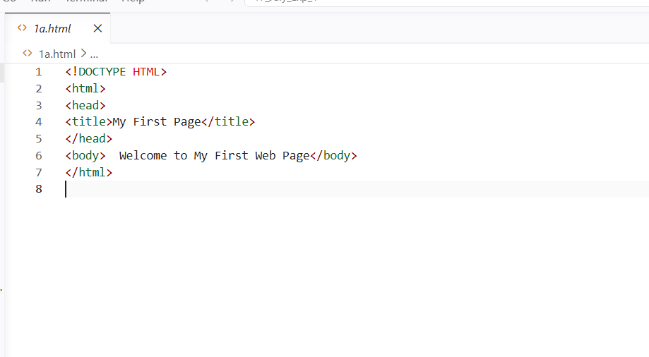
Output
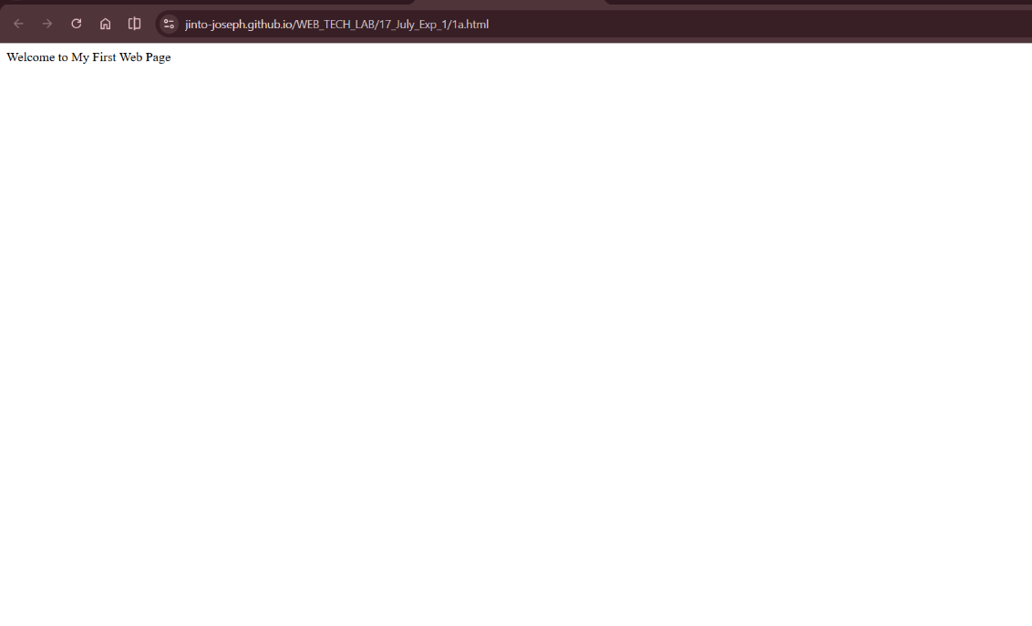

Question 1b
Program
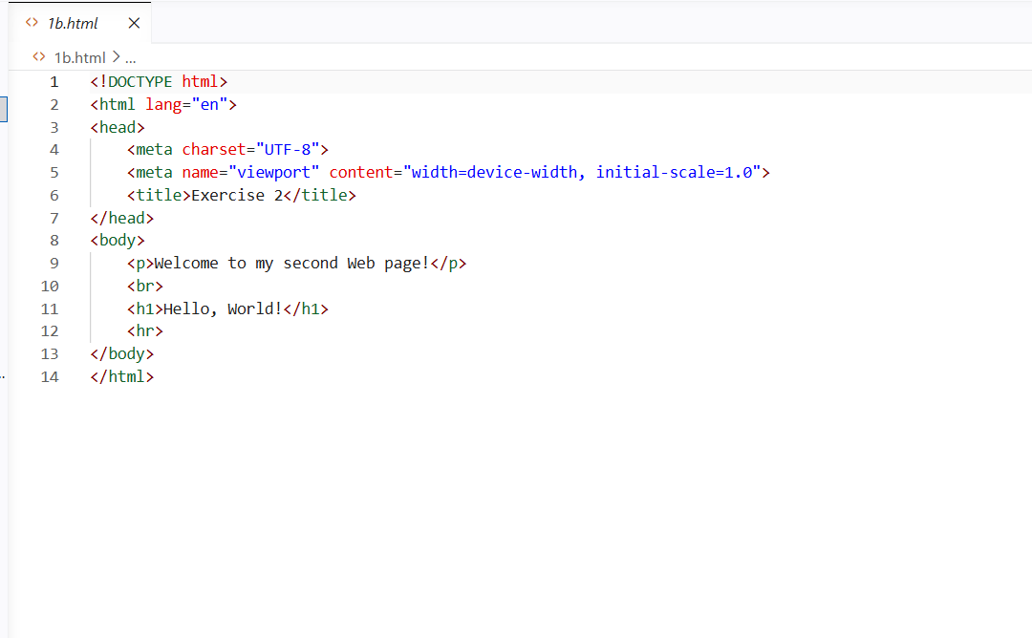
Output
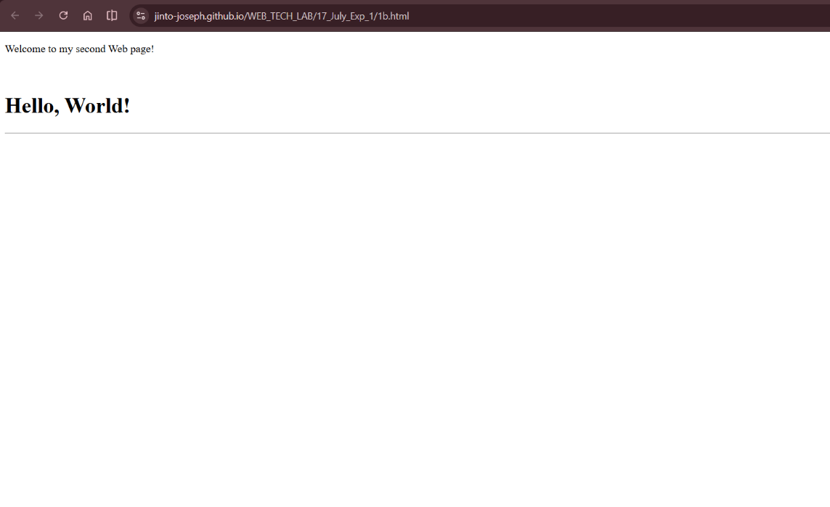

Question 1c
Program
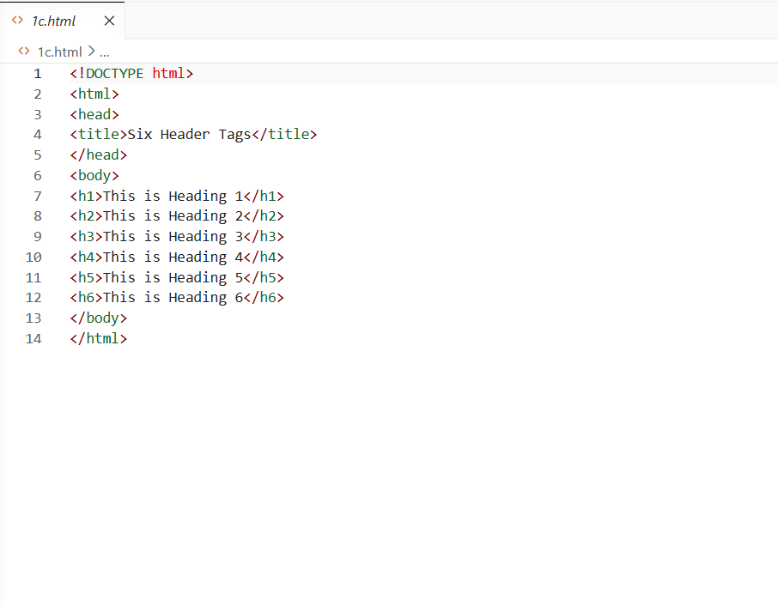
Output
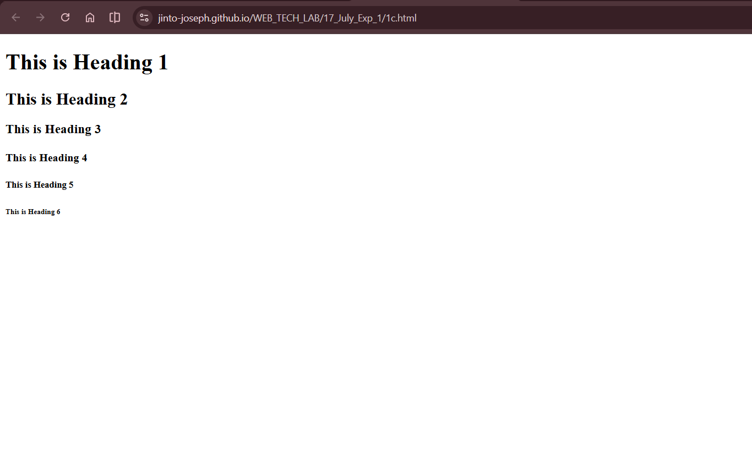

Question 1d
Program
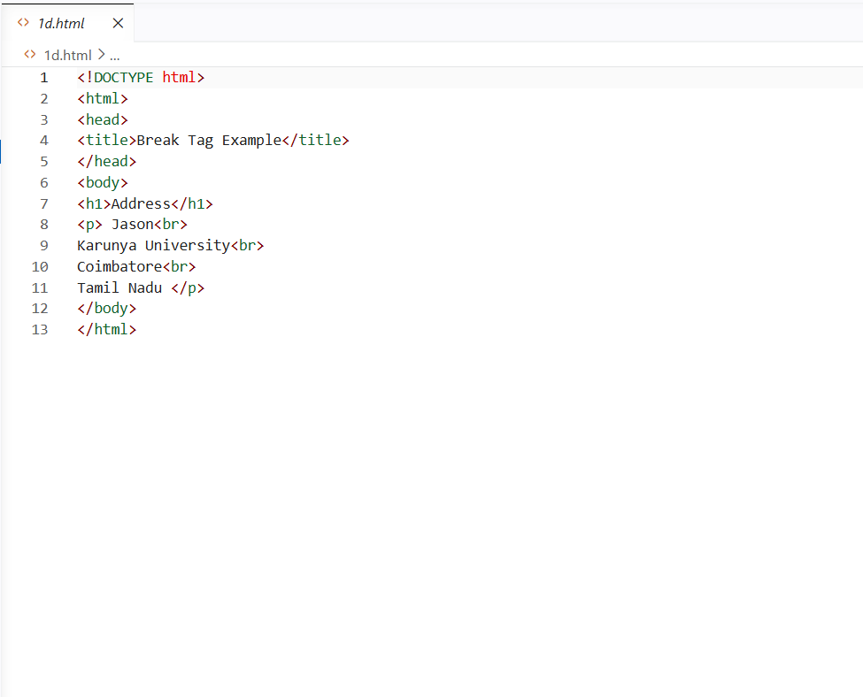
Output
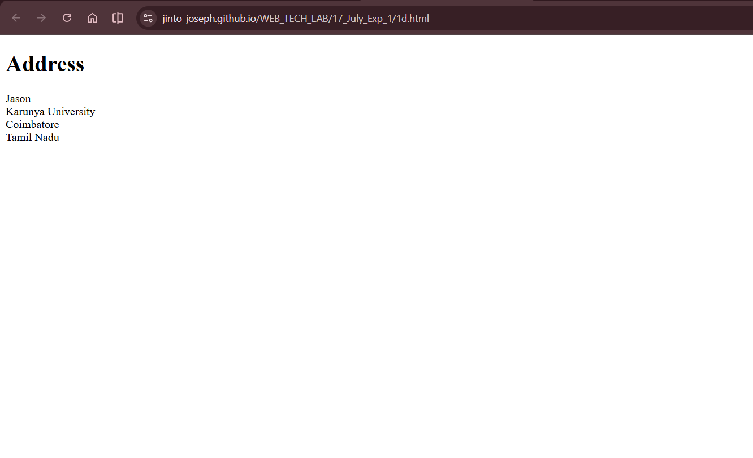

Question 1e
Program
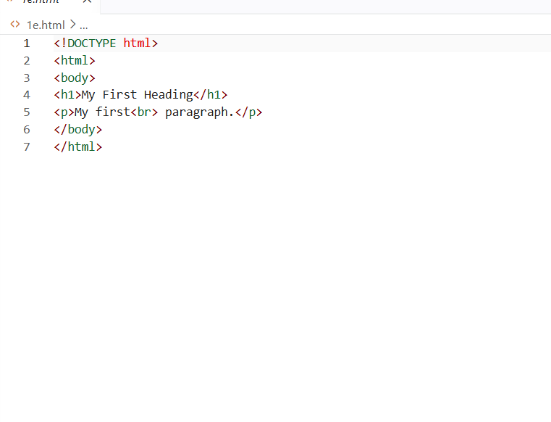
Output
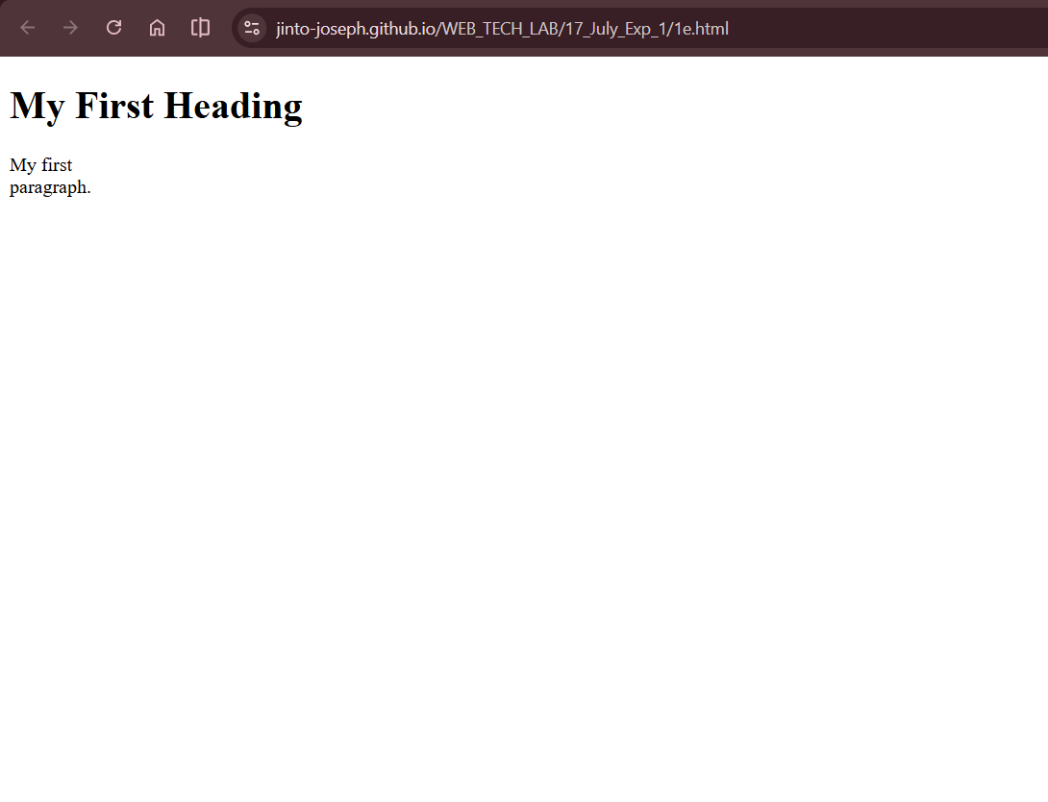
Question 1f
Program
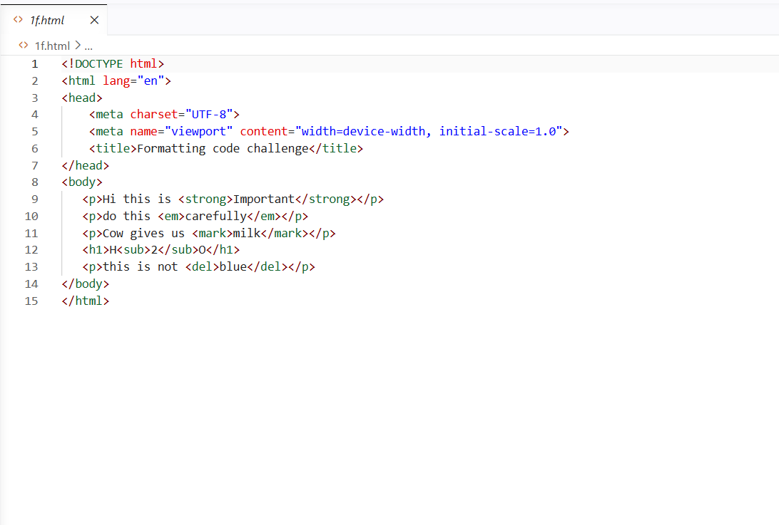
Output
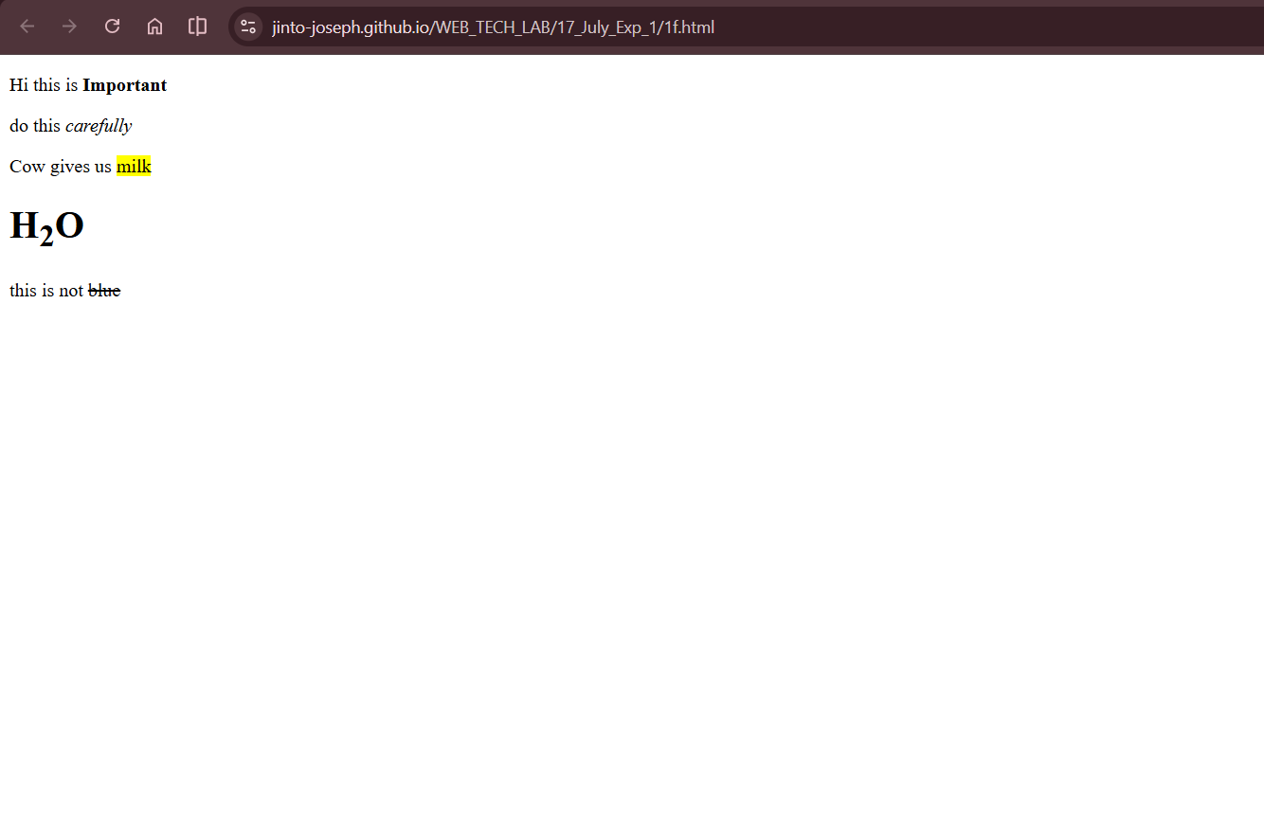

Question 1g
Program
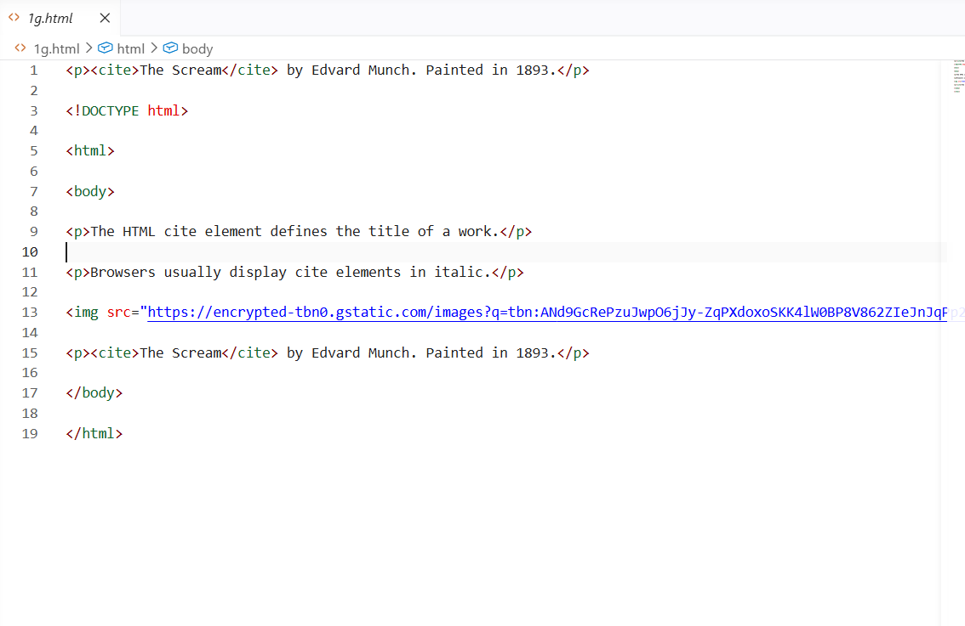
Output
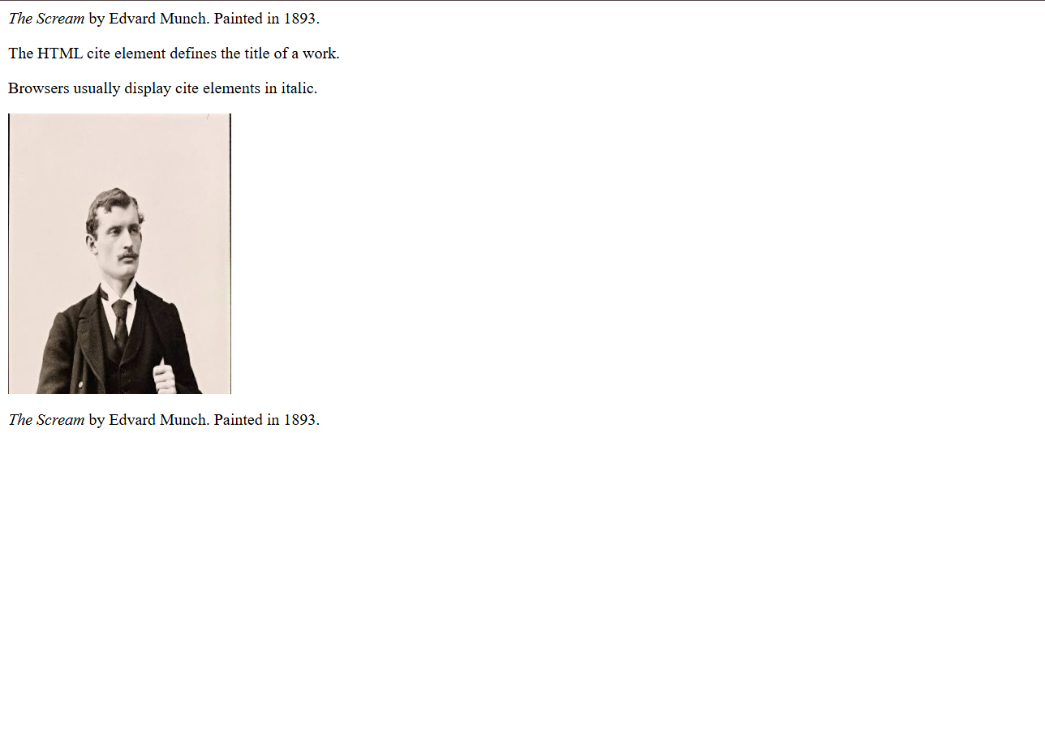
Question 1h
Program
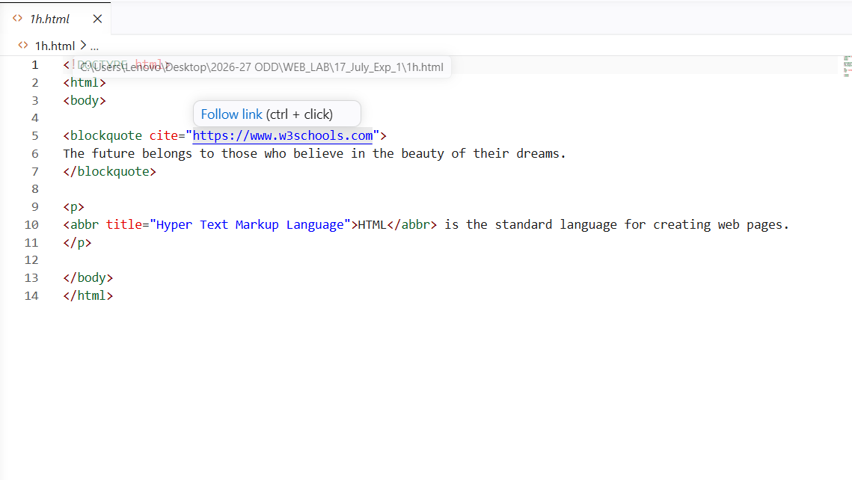
Output
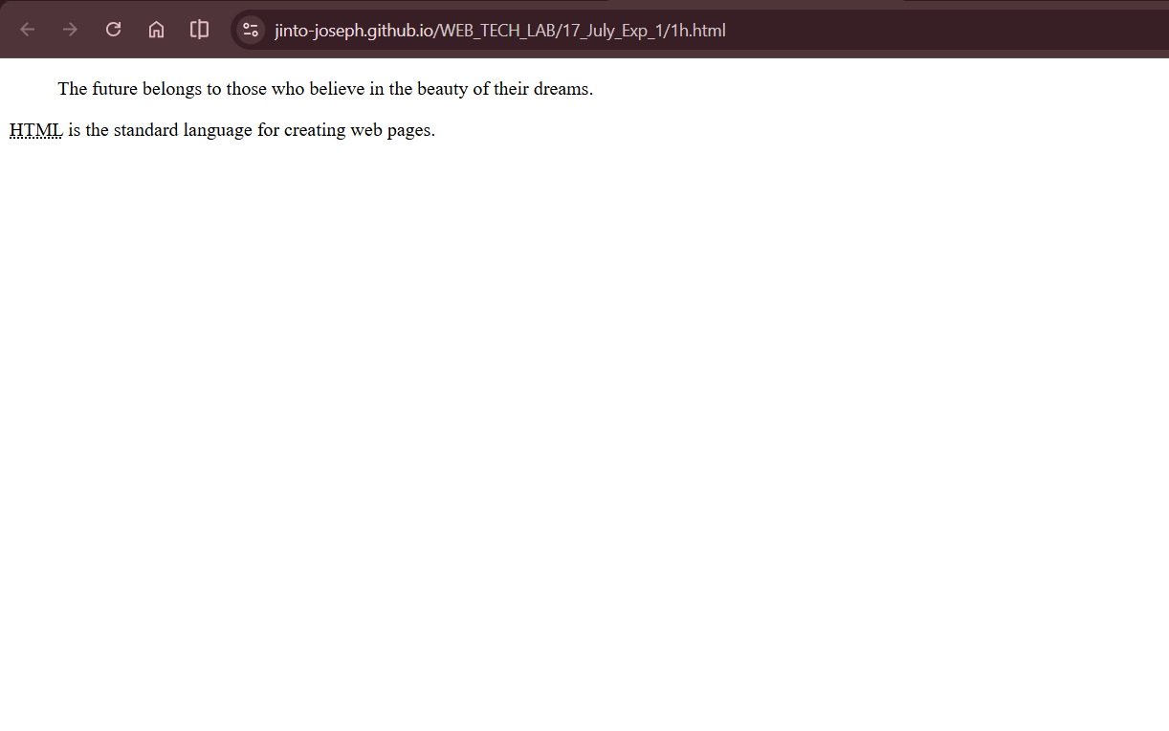

Question 1i
Program
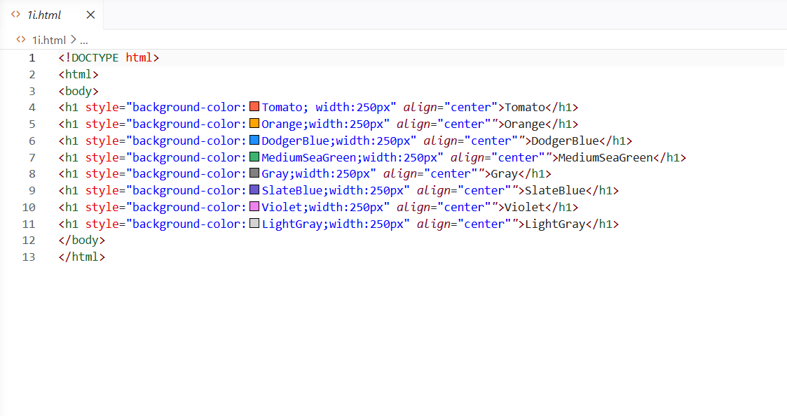
Output
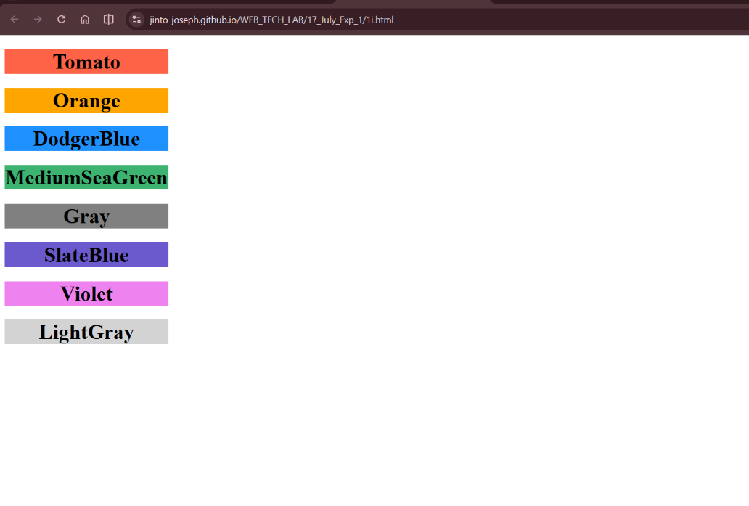

Question 1j
Program
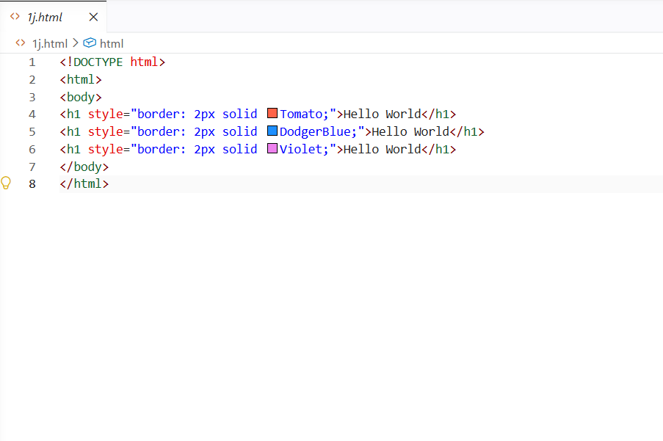
Output
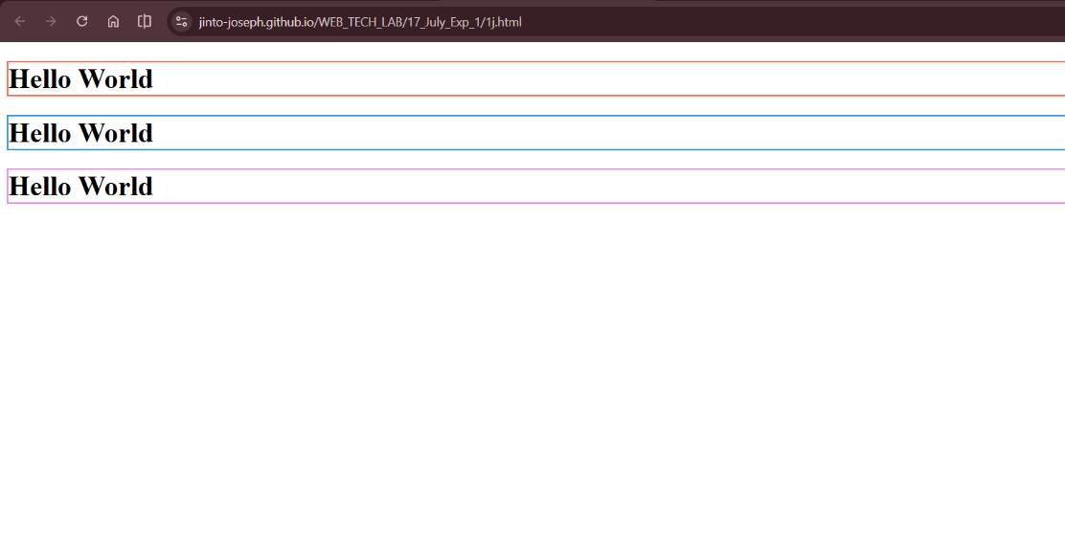

Question 1k
Program
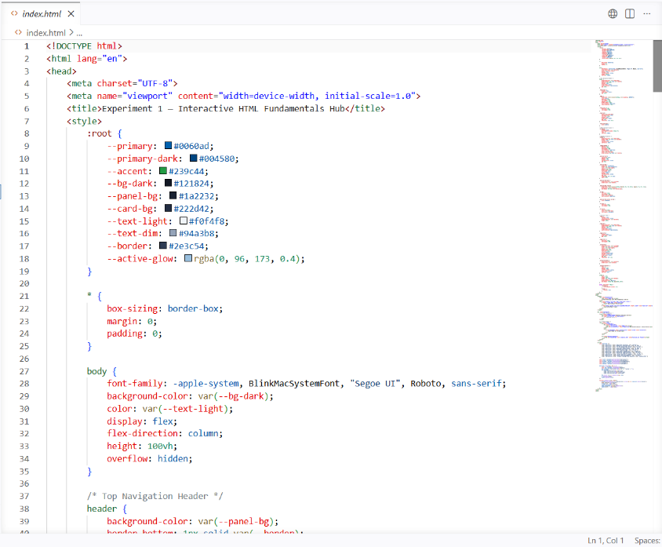
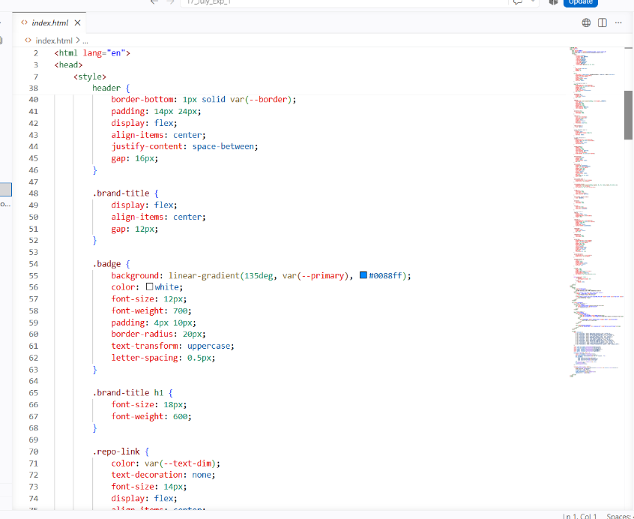
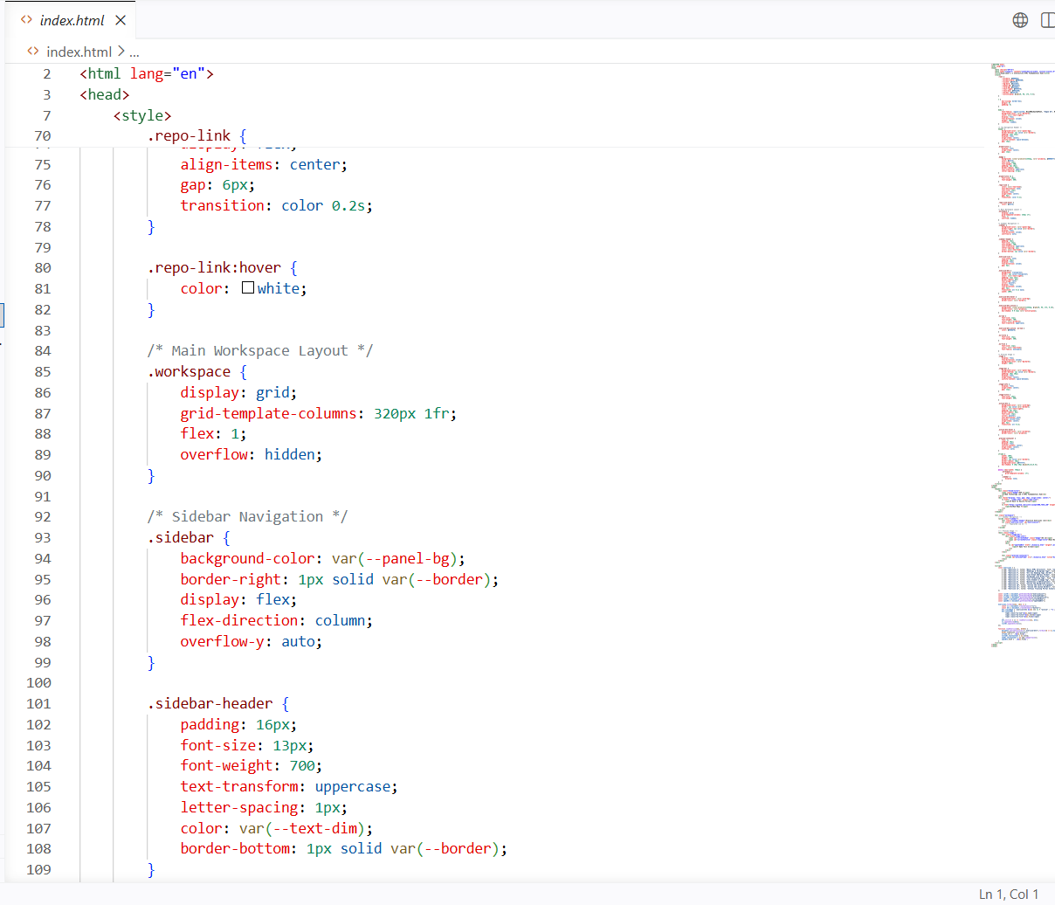
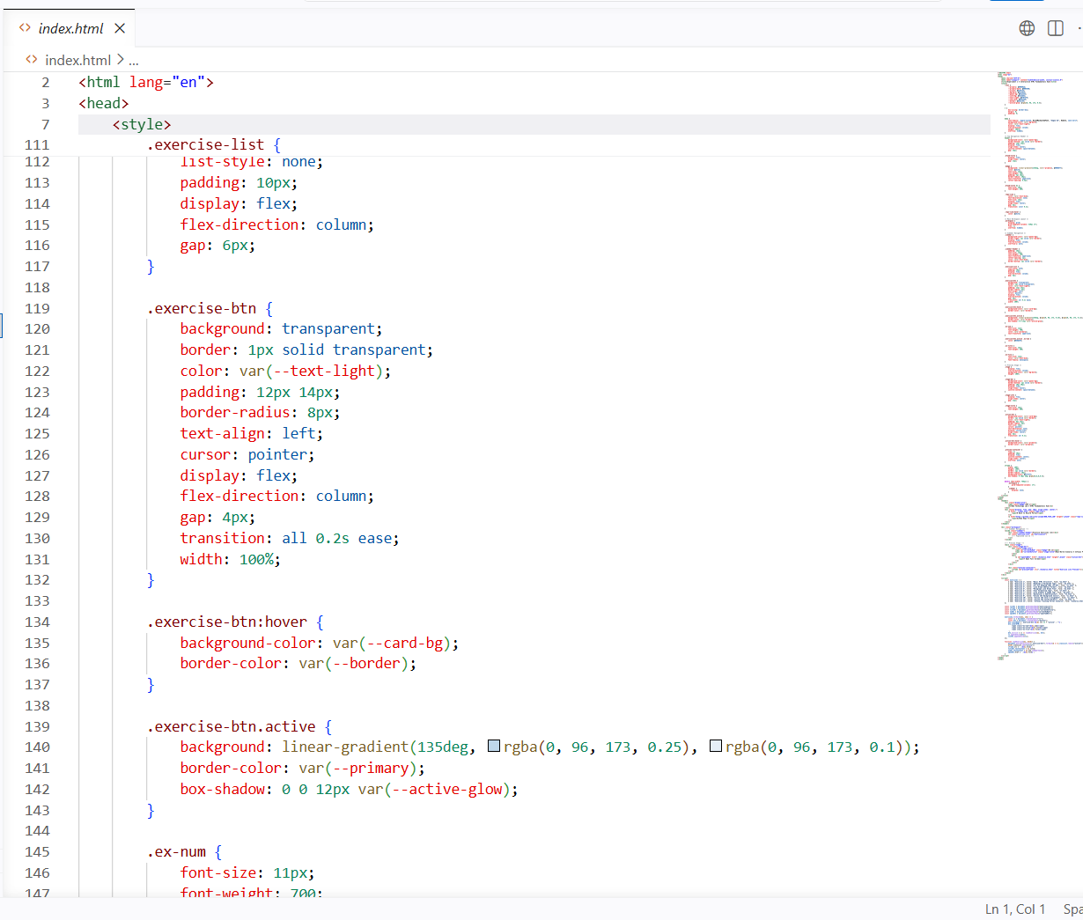
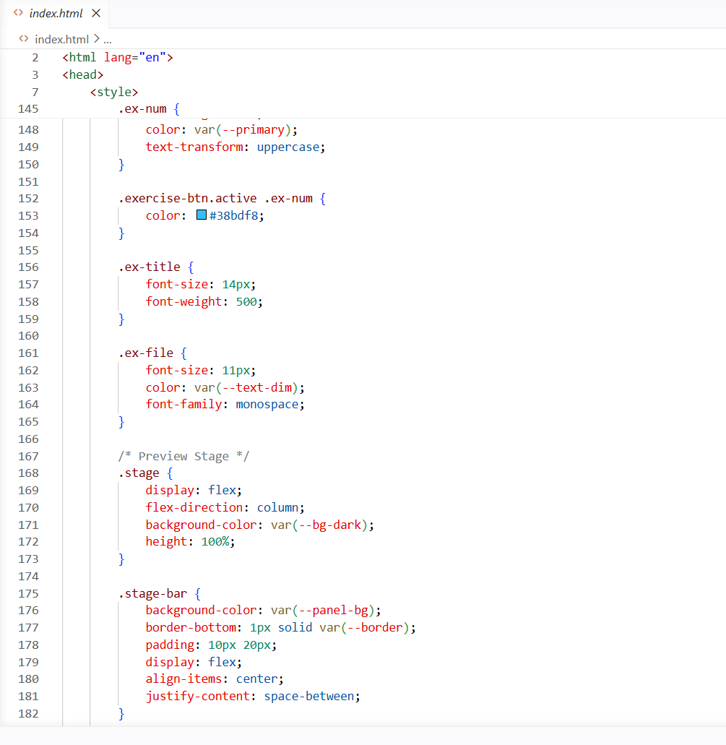
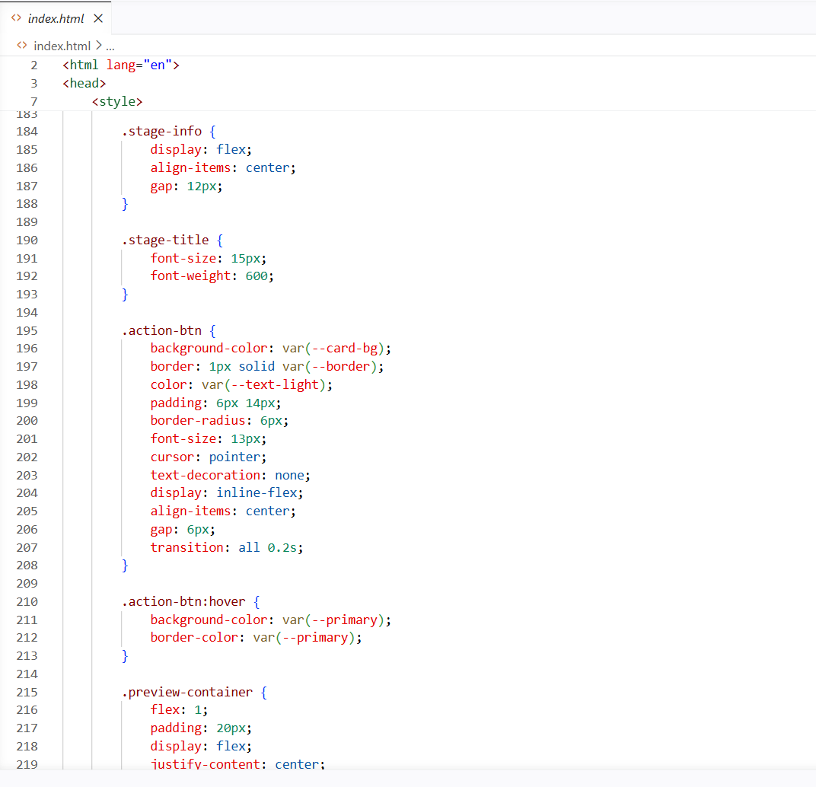
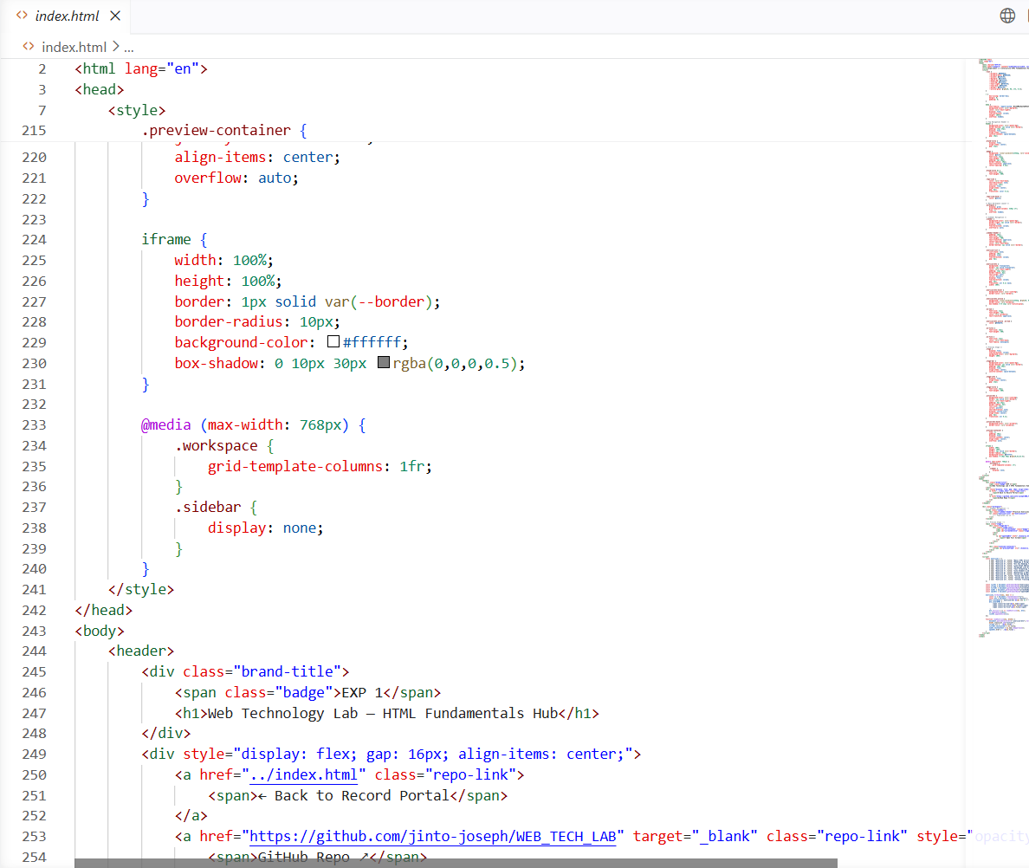
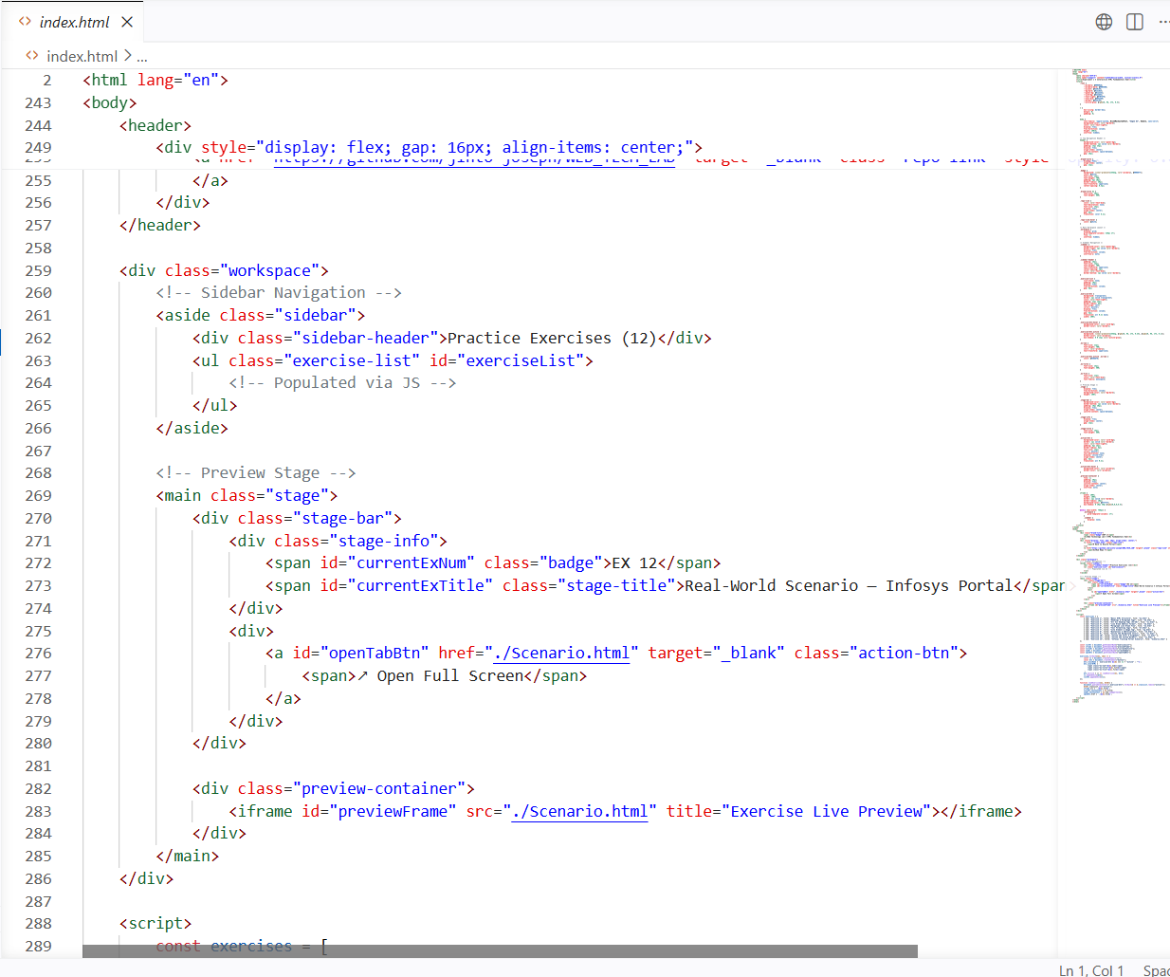
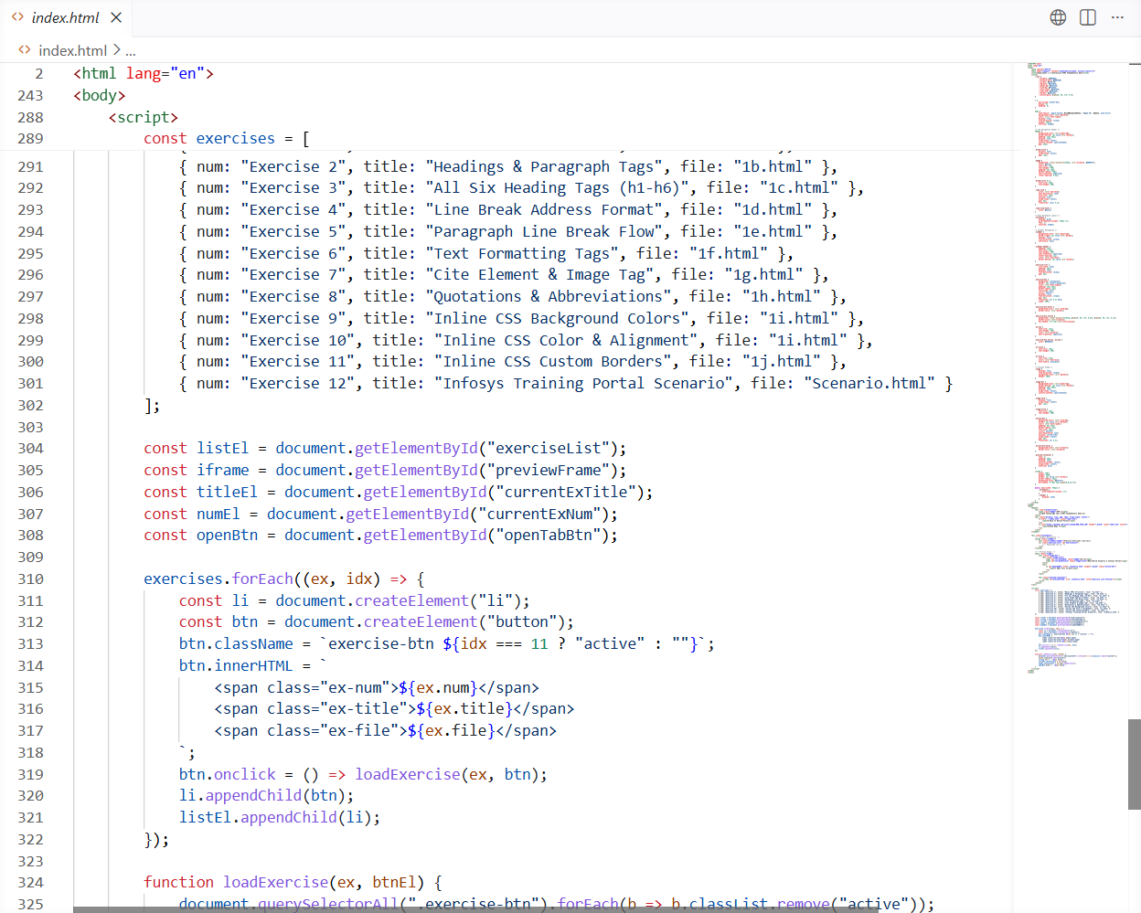
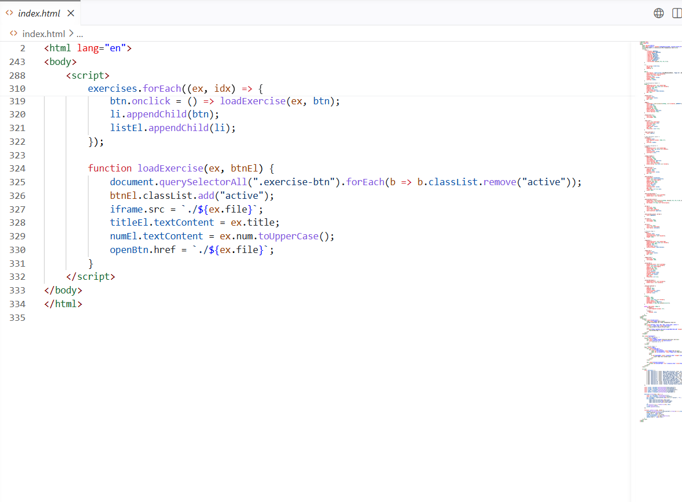

Output
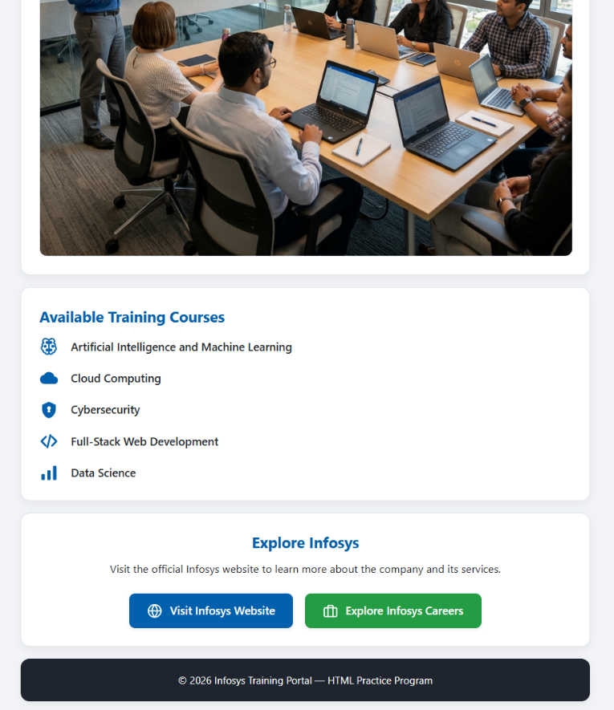
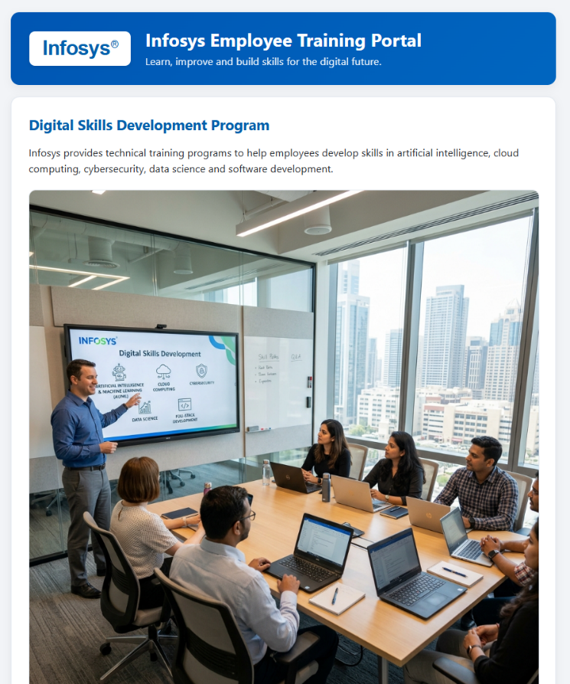

Result
The Infosys Employee Training Portal webpage was successfully created using HTML and inline CSS. The webpage correctly displays the company logo, training information, course list, navigation links, and footer with an attractive layout, meeting all the requirements specified in the experiment.

